GOVERNMENT HIGH SCHOOL
SINDHI JAMAAT CO-OPERATIVE HOUSING SOCIETY, KARACHI
REPORT ON SUMMATIVE ASSESSMENT (3rd Year – 3rd Quarter)
Total Student Strength: 483 Classes: Grade 1 to Grade 9
Venue: Respective Classroom Date : 27 Feb 2025 – 13 March 2025
1. Introduction:
The summative assessment was held during the Final Term of the 2024–2025 academic session to evaluate the academic performance of students across various grades. It served as a comprehensive review of the concepts taught during the term.
2. Objective:
- To assess the knowledge, understanding, and application of concepts by students.
- To provide feedback on student learning for teachers, students, and parents.
- To guide decisions on promotions and academic interventions.
3. Methodology:
- Subject-wise question papers were developed based on curriculum guidelines and learning outcomes.
- Assessments were conducted in a structured and invigilated environment.
- Answer sheets were evaluated using pre-set marking schemes to maintain objectivity.
- Performance data was recorded and analyzed to identify trends.
4. Observations:
- Most students performed well in language and social science subjects.
- A noticeable gap was observed in application-based questions in mathematics and science.
- Some students struggled with time management during exams.
- Overall discipline and conduct during examinations were satisfactory.
5. Key Focus Areas:
- Enhancing problem-solving skills, especially in STEM subjects.
- Improving written expression and comprehension in lower grades.
- Addressing learning gaps identified through the assessment results.
- Providing support for students with consistently low performance.

6. Recommendations:
- Conduct remedial classes in math and science for underperforming students.
- Organize workshops for teachers on creating more balanced assessments.
- Include more formative assessment practices to track learning continuously.
- Engage parents with regular feedback to support learning at home.

7. Outcomes:
- A clear understanding of student strengths and weaknesses was achieved.
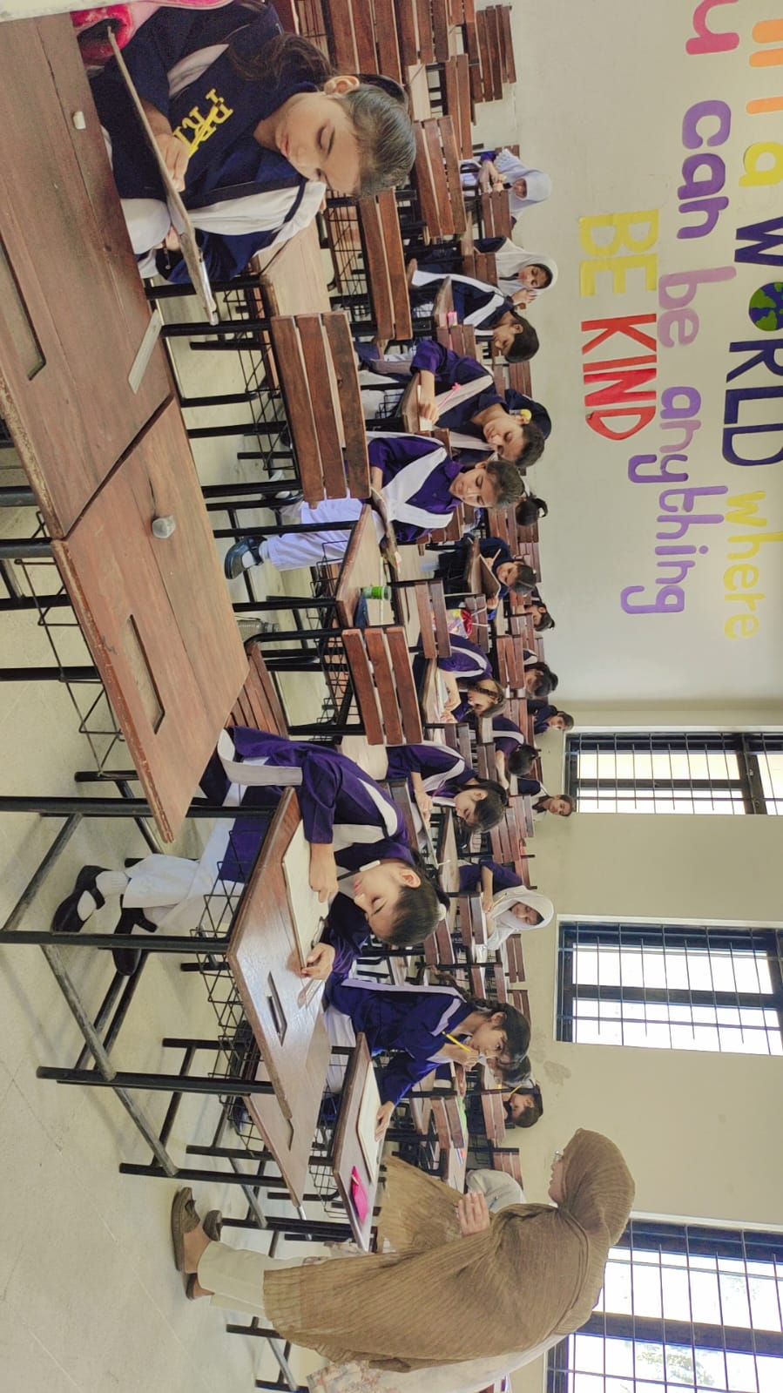
- The assessment results will guide academic planning for the next term.
- Students became more aware of their academic progress and learning needs.
- Teachers are now better equipped to tailor instruction based on assessment data.

